Art History after the ‘Old Europe’ 30 May 2012

Tree House, Humanities Research Centre, University of York
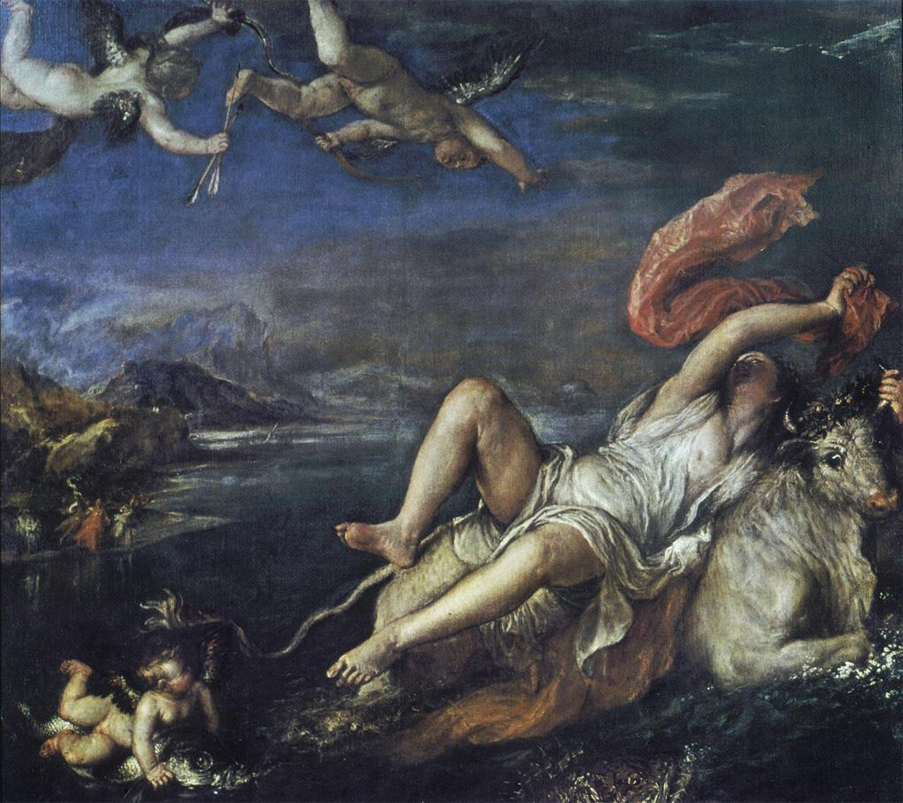

2.00: Introduction: Helen Hills (York)
2.00-2.30: Claire Farago (University of Colorado at Boulder)
2.30-3.00: Ashley Thompson (University of Leeds)
3.00-3.15: Discussion

3.15-3.30: Tea

3.30-3.50: Helen Hills (York)
3.50—4.10: Chad Elias (York)
4.10-4.30: Sarah Monks (UEA)
4.30: Discussion

Drinks in History of Art Department

